

# Business Side of the Sustainable Woolen Market: Revised Analysis Report

**GENG 8000-3-R-2022W (Engineering Technical Communications Section 3)**

Assignment #3b (Individual):

To

# Prof. Jesse Ziter

Submitted by: Anandh Skaria (105156110) Submission Date: March 21st, 2022.

**Current Market of Woolen Industry:**

We cannot come up with a specific period stating the start of the woolen industry, because even before biblical times, we have read about the importance of woolen dress in the world.

The key metrics for the success of any revised or new business plan are:

* Customer Satisfaction:

The existing customers should be feeling comfortable with the new product

* Count the New Customers:

We should bring the message to the public the reason for this change and this good cause along with the quality of the product will produce more happy customers who love to protect our nature.

* Financial Statement:

Since this is a big change made to the manufacturing, we should start with a one month financial statement, compare it with old ways and convince the owners about the risk-free change.

* Self- Analysis:

There should be self-assessment, targets to achieve. Our aim shouldn’t be to be just above the old ways but to dream much bigger.

**The Bad Impact of the Fast Fashion in the current World:**

In current scenario, the world is getting polluted on daily basis due to fast fashion trend of the world and wool is the best alternate for fixing this due to its sustainability factors like sustainable material, natural biodegradable material which causes on harm if thrown away, last longer[https://www.worlds-finest-wool.com/what-role-does-wool-play-in-a-sustainable-fashion-industry/]

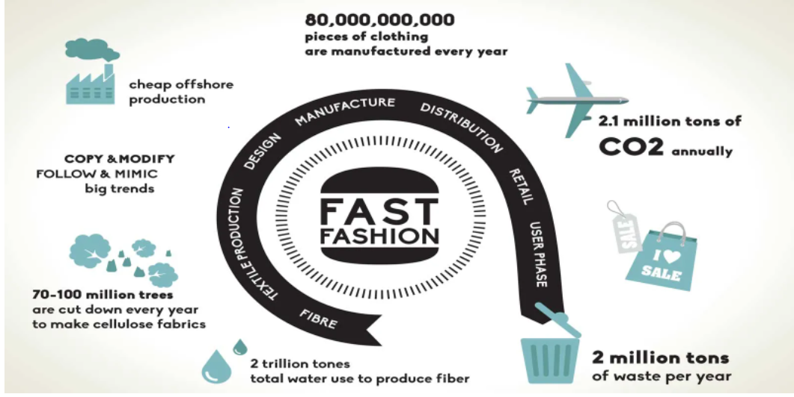

Figure 1: Current Standard of Fashion Industry

**Proposed Business Model:**

The Introduced Model needs less effort compared to the usual ways. Below diagram shows wool production in both ways:

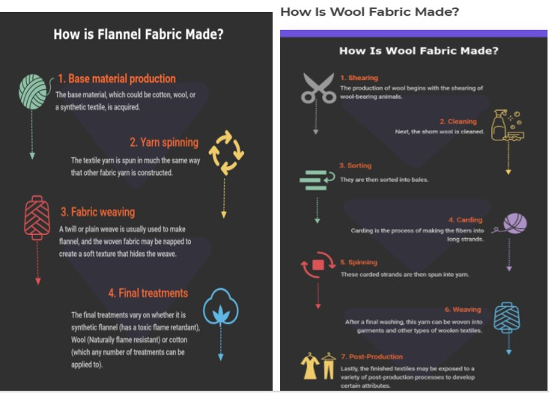

Figure 2: Flannel fabric [2] and animal wool fabric production [1].

The initial cost of cultivating vegan wool and its processing is the area where more amount needs to spend because it’s a new start.

**Stakeholder affected with the Project:**

There are mainly 4 stakeholders affected with this project. They are shareholders, customers, suppliers, and employees. [https://www.investopedia.com/terms/s/stakeholder.asp]. Our team focuses on checking through the concerns of all the stakeholders and make everyone happy. Shareholders here in this project will be the same owners who are already invested in wool manufacturing (non-vegan wools).Our main focus is to convince them with the stats showing them the profit. Customers are the second stakeholders whom should be convinced and in the key metrics we are mainly focusing on the customer satisfaction. Suppliers provide transportation of the goods to employees and theyn are the people who interact with the customers [https://www.inc.com/encyclopedia/supplier-relations.html]. Employees are our most important customers because **they can provide crucial insights into the overall customer experience** [https://www.coriniumintelligence.com/insights/are-employees-more-important-to-your-business-than-customers ]

**Geographical Scope of the Project:**

Our team has decided on taking Australia as the geographical scope of the project. The total value of the wool clip to the Australian economy in 2018-19 was AU$3.4 billion with around 200,000 people employed in the Australian wool industry. Australia invests more than any other country in wool research and development (R&D). This shows the long-standing commitment to supporting sustainable industry growth and development held by both Australian wool growers and the Australian government. [https://trustinaustralianwool.com.au/australian-wool-in-a-global-context/#:~:text=Australia%20is%20the%20largest%20exporter,19%20was%20AU%243.4%20billion.] . Australia as a nation already supports sustainable development and if we are coming up with this change, we will be getting support from the government financially and legally [4].

Today, **Australian cotton growers produce more cotton on less land, with more efficient water use and with less impact on the environment than ever before**. Click here to read our industry's Sustainability Reports. Our vision is for Australia to be a global leader in sustainable cotton production.[ <https://cottonaustralia.com.au/sustainability> ]

**SDG:**

Through this change, we are making good impacts on two of the Sustainable Development Goals- Climate Action (13) and Life on Land (15). The introduction of vegan wools will stop the overgrazing done by flocks which had resulted in soil erosion. [ <https://en.wikipedia.org/wiki/Overgrazing> ] The cruelty done towards animals on shearing will be prevented through this change. [https://www.bclaws.gov.bc.ca/civix/document/id/complete/statreg/96372_01]

## Value Proposition

The plan is to make woolen cloth products like woolen sweaters, woolen jackets, woolen socks, and woolen scarfs. The priority of our products is customer satisfaction because our products will be top in the quality of the material and reachable for all customers. We will be having a proper continuous customer survey, focusing on each customer with their precious reviews and surveys on the product.

## Room for the change in the Current Industry

In today’s world, the population is worried about the sustainability of the environment because according to the present flow, the life of the future generation will be at risk and people are aware of that. So sustainable methods are always accepted by the people and government.

## References

1. Sewport Supporting Team. “What is Wool Fabric: Properties, how it’s made and where”. Sewport. https://sewport.com/fabrics-directory/wool-fabric (accessed March 20, 2022)
2. Sewport Supporting Team. “What is Flannel Fabric: Properties, how it’s made and where”. Sewport. https://sewport.com/fabrics-directory/flannel-fabric (accessed March 20, 2022)
3. S. Kesari. “World’s largest wool-producing countries”. Geographynotes. https://www.geographynotes.com/wool/worlds-largest-wool-producing-countriesgeography/ 5526 (accessed March 20, 2022).
4. “Australia”. Sustainabledevelopment. https://sustainabledevelopment.un.org/memberstates/australia#:~:text=Australia%20has%20long %20recognised%20the,outcomes%20enshrined%20in%20the%20SDGs (accessed March 20, 2022).